Training in Occupational & Environmental Medicine
An applicant’s guide, by Matthew Hamm, MD, MPH
OEM Resident, Harvard, class of 2024
Did you know that occ med is the most satisfying field of medicine with the least burnout (source: JAMA data)? If you want to broaden your professional scope to care for workers, if your current job doesn’t fulfill you, or if you simply desire the best work-life balance in residency and beyond, then congratulations on discovering the hidden gem of medicine, occupational & environmental medicine (OEM)! Yes, you can have it all and make a big impact. The process of applying to residency in OEM is slightly different from other specialties, so let’s talk about how to do it. We created this hub of information for aspiring occ docs because OEM is a small field—you may not have peers or mentors with current knowledge about the process. Click to download a copy of Training in OEM: an applicant’s guide.
Would you like to connect with someone to discuss the specialty or training in OEM? Contact Erin Ransford, ACOEM's Director of Engagement, at erin@acoem.org to speak with one of our OEM ambassadors!

Why OEM?
Imagine how your perfect day at work would go. Workload, practice setting, procedures? Schedule, pay, variety? Employer type, consultant, entrepreneur? Program administration, population management, R&D? Like the golden days of medicine, occ med still offers any lifestyle or practice style you can think of. If you’ve never loved being on call and can’t stand long shifts, OEM might be right for you.
The future is bright! The current occ med workforce is aging (oldest of any specialty), and nationwide demand for board-certified OEM physicians continues to rise. The intersection between healthcare complexity and workplace responsibility creates an opportunity for doctors to bridge workers with employers. Also, OEM-trained physicians can pursue the growing environmental and public health facets of this diverse field. ACOEM members can check out jobs here https://acoem.org/careers.
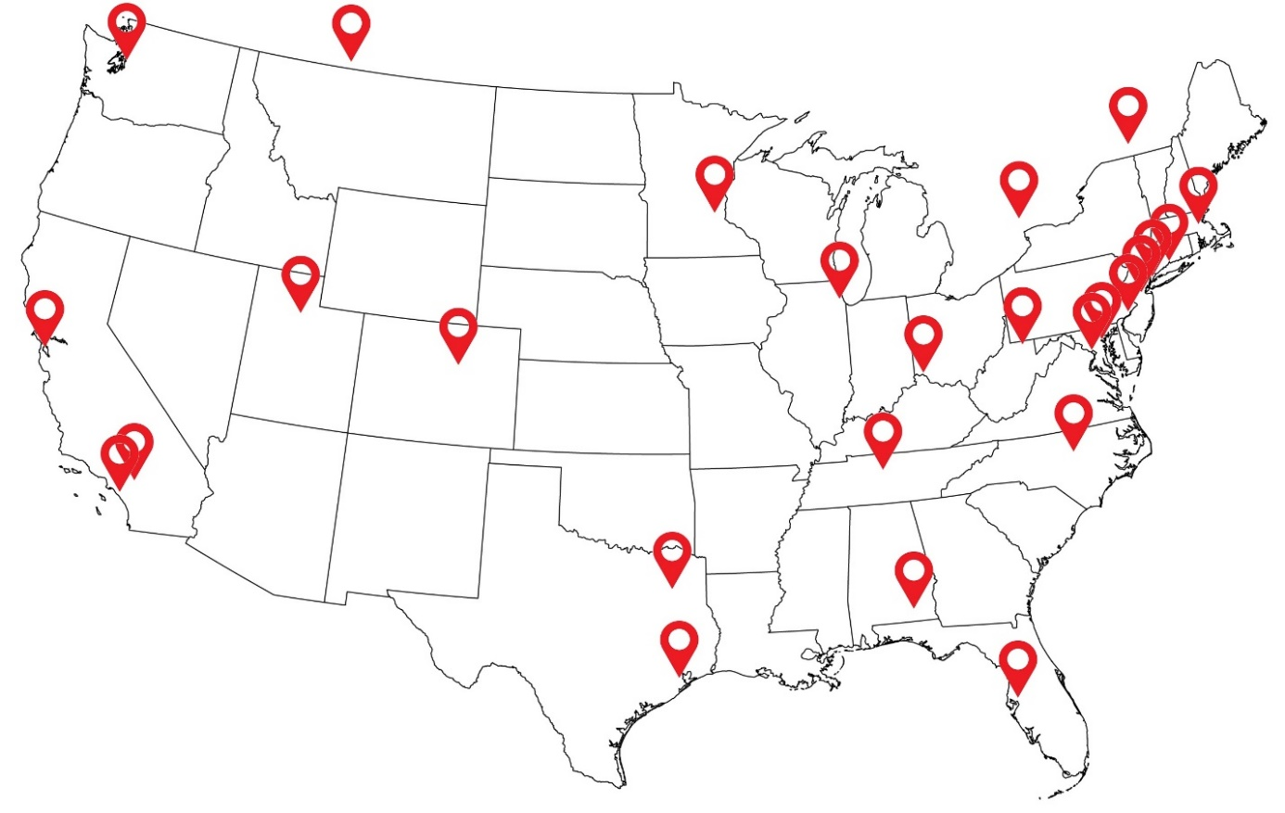
Figure 1. A map of the 26 OEM training programs in the U.S. and Canada, 2023. Data source: AOEC
Table 1: Web links to the 26 OEM training programs in the U.S. and Canada, 2023. Data source: AOEC
Program | City | State
United States Army | Fort Rucker | Alabama
Loma Linda University | Loma Linda | California
University of California-San Francisco | San Francisco | California
University of California, Irvine | Irvine | California
University of Colorado Denver/Colorado School of Public Health | Aurora | Colorado
Yale Occupational and Environmental Medicine Program | New Haven | Connecticut
University of South Florida | Tampa | Florida
University of Illinois at Chicago | Chicago | Illinois
Harvard T.H. Chan School of Public Health | Boston | Massachusetts
Johns Hopkins Bloomberg School of Public Health | Baltimore | Maryland
Uniformed Services Univ. of the Health Sciences | Bethesda | Maryland
HealthPartners Occupational & Environmental Medicine Residency | St. Louis Park | Minnesota
Rutgers Occupational & Environmental Medicine Program | Piscataway | New Jersey
Icahn School of Medicine at Mount Sinai | New York | New York
Duke University | Durham | North Carolina
University of Cincinnati Occupational Medicine | Cincinnati | Ohio
University of Pennsylvania | Philadelphia | Pennsylvania
Meharry Medical College | Nashville | Tennessee
University of Texas Health Science Center at Tyler | Tyler | Texas
University of Texas Health Science Center at Houston | Houston | Texas
University of Utah | Salt Lake City | Utah
University of Washington | Seattle | Washington
West Virginia University School of Public Health | Morgantown | West Virginia
Occupational Medicine Program University of Alberta | Edmonton | Alberta
Université de Montréal, Faculté de médecine | Montréal | Quebec
University of Toronto | Toronto | Ontario

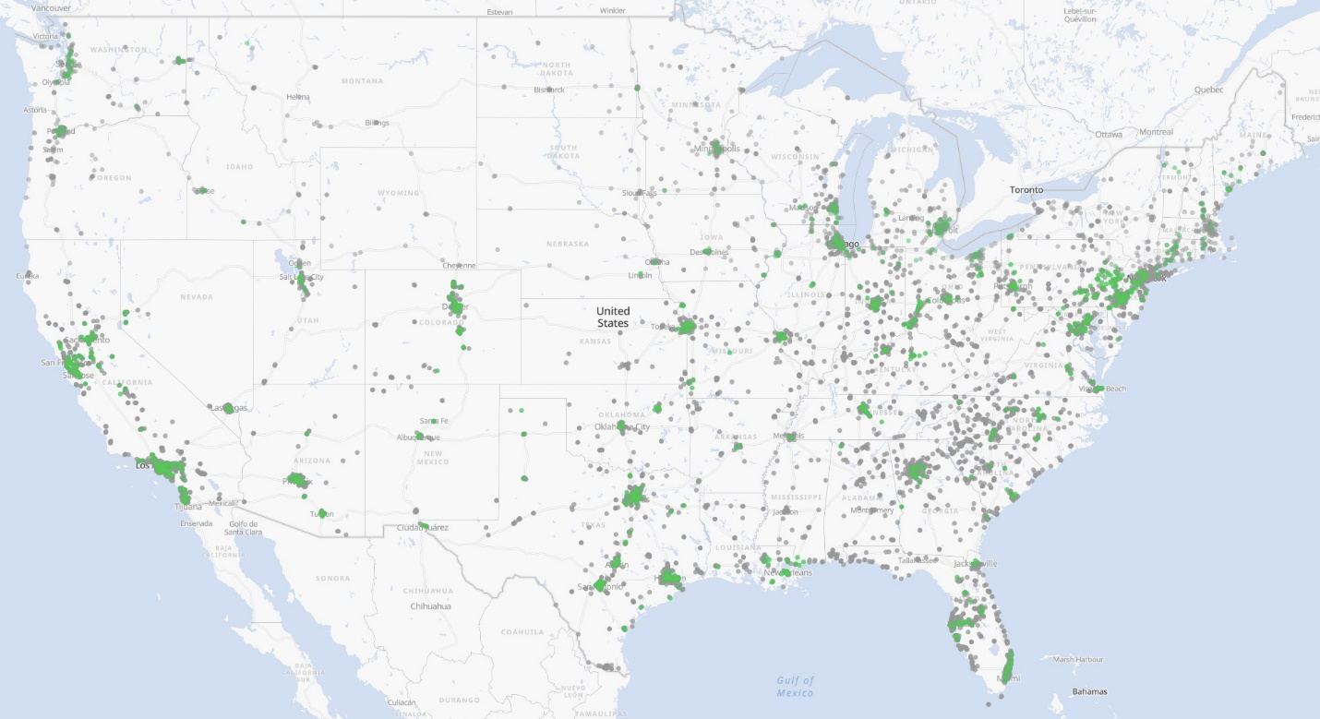
Figure 2. A map of OEM job openings in the United States, 2023. Source: ACOEM/OEM Explore
Occ med is one of three specialties under the American Board of Preventive Medicine, along with Public Health and General Preventive Medicine (PH/GPM) and Aerospace Medicine. Occ med is more clinical than GPM and focuses on workers and workplaces. Aerospace is the smallest and most focused field and is popular within the military and air transportation. All three specialties have similarly-structured residencies and a broad range of opportunities for work upon graduation. If you haven’t considered GPM or Aerospace, now is the time to see if they might be right for you. ABPM offers four fellowships if you want to subspecialize further: Addiction Medicine (the largest), Clinical Informatics, Undersea & Hyperbaric Medicine, and Medical Toxicology.
Many physicians transition to practicing in OEM after training in traditional clinical fields, such as internal medicine and family medicine (mid-career transition). Many primary-care and acute-care clinics diversify their cases with basic occ med services. However, the most rewarding jobs require board certification in occ med, which usually requires residency in occ med. ABPM certifies a smaller number of diplomates via their Complementary and Special pathways, although the Residency path is most common.
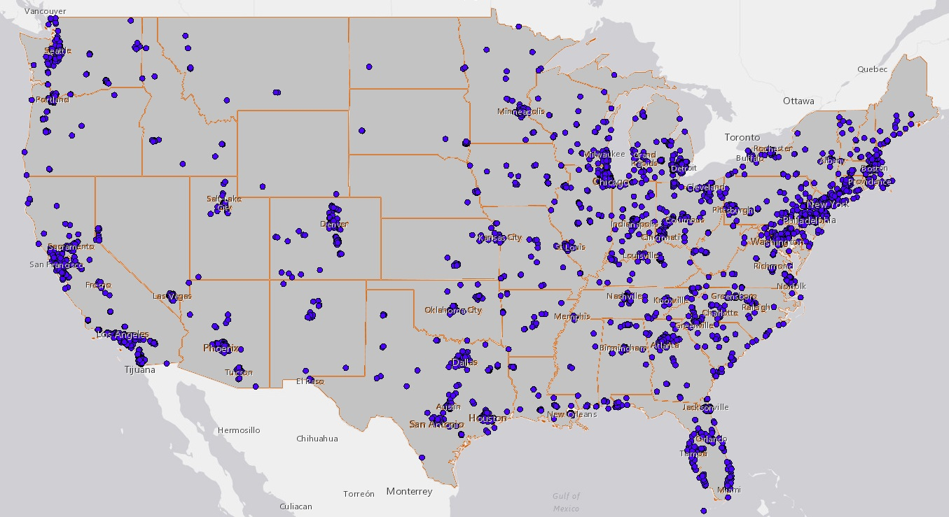
Figure 3. A map of practicing OEM physicians, United States, 2023. Source: AMA/Workforce Mapper
“My experiences in the military and interest in musculoskeletal medicine drew me to apply. OEM has a myriad of career opportunities. It's perfect for someone who prioritizes variety, work-life balance, and family.”
–Karl Nielson, DO, MOH. University of Utah, class of 2024
Why haven’t you heard of occ med before? Medical schools focus on the most common specialties, and the prev med specialties are small by comparison. This lack of exposure continues through graduate medical education (GME) as well. Payment for OEM services is often outside traditional health insurance, so practicing physicians infrequently consult their OEM counterparts. Many OEM clinicians discover the field after practicing independently for several years. Some expand their practices to include bread-and-butter OEM clinic services, whereas others join full-time OEM jobs. Yet others pursue full-time training in occ med through a 2-year residency leading to board certification, which is the main path this guide will help you navigate. Well-prepared applicants often have such prior work experience, sometimes in the military or in other clinical residencies.

How do I apply?
“I found out about OEM from a friend of a friend when I was considering changing specialties. I reached out to alumni of different programs and found that everyone was happy to share their experiences in this little-known corner of medicine. After interviewing across the US, I received offers from several programs. I am very happy that I made the change.”
–Max Blumberg, MD, MPH. UCSF, class of 2024
There are three electronic application systems used by US occ med residencies. There are 23 OEM residencies across the continental US—21 civilian and 2 in the military. Canada offers another 3. Each program’s website details their specific requirements, but 18 of the US civilian programs require nearly identical documents to apply. There are three online application services that you should at least be aware of; listed below.
An exception is the University of Pennsylvania, which does not use an electronic system. They offer two distinct programs: the internal track (traditional residency) and the external track (part-time Complimentary Pathway). Their external track has a structure that is unique in the nation. If you are mid-career and desire to continue working full-time in occ med while becoming board eligible, reach out to UPenn to discuss if their external track might be right for you. Several other programs have also accepted complimentary residents in recent years. If you are already board certified in another specialty and want to become board certified in OEM without going back into GME full time, consider reaching out to an OEM program near you to see if they can accommodate a complimentary resident. The Complimentary Pathway, other non-traditional, or off-cycle arrangements are typically applied for and matched outside of the processes we will discuss further down this page.

ERAS
The Electronic Residency Application Service (ERAS) is the largest online application service for GME, covering nearly all specialties and nearly all programs.
Timeline: you may begin entering information in June, but you cannot fully submit the applications to programs until early September. Don’t worry if you didn’t start in June—programs cannot see your application until a published date in late September (search “ERAS residency timeline”). Some programs review your application the first day they can. They are trying to find applicants who meet their qualifications to offer interviews. Each university has a limited number of interview slots. This works on a rolling basis. If you submit your application to programs after the opening date, you should recognize that other applicants may have been invited to interview already, so you are competing for fewer available interview slots. ERAS’s broad application window (September through December) suggests you’re not late as long as you get your application in by November, which may be true for other specialties. However, because OEM matches several months before other specialties, your application will be effectively behind the competition if programs don’t receive it near the opening date (late September).
Prior to 2022, OEM was listed in ERAS jointly with GPM. However, now you can see all the OEM programs that participate in ERAS. The two active-duty military programs (USUHS and Fort Rucker); the Canadian programs; and Johns Hopkins, Harvard, and UPenn do not use ERAS. All the other 18 programs currently do. This distinction changes from time to time, so if you don’t see a program you’re looking for in ERAS, just check their website or email the program’s coordinator.
There are excellent guides out there regarding how to successfully complete the various sections within ERAS. Pay particular attention to the Experiences section. You are allowed to customize a Personal Statement separately for each program, not just for each specialty (if you are applying to multiple specialties). Consider waiving your right to see letters of recommendation, as this allows readers to more fully trust that the author is sharing their genuine support of you.
ERAS/AAMC plans to release applicant data for OEM soon separately from other prev med specialties, although currently (April 2023) the only available data is pooled. This will allow you to see the number of applicants per program, programs per applicant, information about applicants’ medical schools, and basic demographic breakdowns.

SOPHAS
The School of Public Health Application Service (SOPHAS) is similar to ERAS in function. It allows you to send a standard set of information to schools. Although mainly used by MPH programs, it is also used by two OEM residencies: Harvard and Johns Hopkins. The three application services do not communicate with each other, they have different fees, and they require data to be input in different formats. However, your core documents are the same. If you’re thinking about skipping applying to SOPHAS-only programs (H & H), remember that your ERAS residency might require you to go through SOPHAS anyway after Match Day to apply to their in-house MPH program that spring, so you may not save time or money skipping SOPHAS in the fall.

MODS
Military applicants must use the Medical Operational Data System (MODS) to apply to the two military programs. Additionally, Air Force “civilian sponsored” and Navy “full-time out-service” (FTOS) applicants seeking their service’s sponsorship for civilian residencies must use MODS to secure funded billets, in addition to using the other application systems for specific programs. Although the deadlines and process for ERAS and SOPHAS are similar to each other, MODS requires additional military-specific documents and preparation, and they operate under a timeline earlier than the other two application systems. Air Force and Navy applicants for civilian sponsorship (FTOS) will interview with their service’s Occupational Medicine consultant to compete for funding. Then they will interview with civilian residencies before they know if they are selected for military funding. Applicants learn about their military funding status before civilian programs can offer spots, so there is time to influence that decision.

What are Residency Selection Committees looking for?
The Personal Statement (PS) is a powerful tool. Yours should be customized for OEM if you are applying to multiple specialties. You may also customize it to each program within OEM. It should reflect your level of knowledge about the field and include any relevant work experience, patients, or projects. Definitely include any military service or public health experience. Many interviewers say that the Personal Statement is the most important document they review when considering who they invite to interview.
Similarly, Letters of Recommendation (LOR) are very important. The authors should be doctors or other OEH professionals you have worked with closely over time. LORs serve to demonstrate your character, capacity, and motivation. The content should be specific to OEM if possible. Details may include snippets referenced in your CV/experiences and PS. All these documents serve to tell a story of someone prepared to succeed in their residency and beyond. Your interviewers will ask about details in these documents, so catch their attention with a range of topics and be ready to tell your stories.
There seem to be three top criteria that all programs use to evaluate candidates: familiarity with occ med and their program, academic capacity, and the applicant’s being a good fit for their program style and needs. Academic capacity is demonstrated by your GPA and standardized exam scores, and it is especially important to residencies because they need you to pass the ABPM occ med boards upon graduation. This is one of the few ways they are evaluated by ACGME. These top three topics should be clearly described and supported in your personal statement and ideally in other areas of your application package.

How would you Select a program?
Where you train matters to some extent. It will provide certain growth opportunities and provide specific experiences as you launch your career in OEM. Above all, you hope to match to a program that aligns with your vision and complements your educational goals. Many American applicants will limit themselves to the 21 US civilian residencies, but if you’ve ever wondered about being in the military or training in Canada, now is the time to explore those categories.

Occ Med in contrast to other residencies
Not only is occ med a pleasure to practice after graduation, your years in residency are unlike any traditional clinical residency. For starters, no one works more than 50 hours per week; 40 is common. Resident salary is usually $60-70,000/year, on par with national averages. Same salary for half the hours equals double the hourly rate, and a lot more happiness. Monday through Friday 8:00-5:00 is typical. Some programs require periodic evening/weekend call (phone at home) or occasional evening/weekend projects, but none require evening or weekend clinical responsibilities. It’s “golden weekend” every weekend.
All US Civilian programs are 24 months and require you to have already completed at least an ACGME-accredited PGY-1 year by the time you begin the residency. Applicants who have completed additional PGY years or are board-eligible in another specialty are attractive candidates to OEM programs. Some programs operate more like a fellowship than a residency, including using the word and title. ACGME considers all OEM programs as residencies. Yale’s program is the only one to specifically require completion of a previous residency.

Some differences between OEM programs
Despite their common features, occ med training programs tend to vary around several topics.
- Emphasis. Any given program will focus differently on clinical care, research, underserved communities, a particular industry (such as agriculture, oil & gas, mining, forestry, biotech, public safety), environmental medicine, or corporate medicine. If you’re interested in occupational pulmonology, there’s a path for that. If you already have a niche in mind, ask around and you might find a good fit.
- Clinic. Day to day this could be the feature you experience most frequently. You will likely have a home clinic in an affiliated institution and several other clinical rotation sites or organizations. Clinic schedule, pace, and patient mix vary widely between programs, as do the availability of procedures and specialized exam types. This includes workplace injuries and illnesses (workers’ compensation), exposure surveillance, toxic environmental exposures, and regulatory exams (DOT, FAA, TSA, Immigration, Mariner). Try to find a program with a supportive culture where the residents enjoy going to work. Learning is better when you’re happy and not too stressed.
- MPH time. Programs vary widely regarding how much time they protect for the MPH (or other master’s degree). Are you expected to attend MPH class in person or remotely during a clinical rotation? How many daytime hours are you given to do your coursework and study? How many classes are in the evening? Some programs protect your work-week schedule to accomplish the entire degree, whereas others expect you to make it fit between other obligations.
- Setting/Location. Some residencies are in the urban heart of bustling cities, whereas others are surrounded by rural farmland. There are residencies in the Midwest, both coasts, mountains, and hot or cold. The difference in cost of housing between the least and most expensive locations is significant, so you should carefully evaluate your finances and obligations (debt, children, hobbies) when considering where to live for two years. The variation in salary does not necessarily correlate with variation in housing costs, so plan your budget and avoid severe financial stress while in training. Also, investigate the commutes between housing you can afford and your main clinic, classroom, and rotation sites, as this varies between programs. Imagine what it might be like to live there for two years. Location lifestyle may be the determining criterion for you and your family.
- Rotations. ABPM requires residents to spend a certain minimum amount of time in clinical rotations and public health rotations. Elective time ranges from 1 to 6 months, depending on your program. Also, the number, variety, and styles of core rotation opportunities varies widely. Certain rotations are virtual. Some programs allow you to stay in one geographic area for the entire 2 years, whereas others require several month-long rotations at more distant sites, requiring alternate lodging arrangements. Some programs have many elective rotation options pre-arranged, whereas others require you to find and set up your rotations.
- Trajectory. What do graduates of each program typically do after graduation? Many programs turn out consistent types of occ docs: clinicians, policymakers/government employees, researchers, academics, or industry specialists. It’s common to switch tracks throughout an occ med career, but if you know which direction you’d like to pursue upon graduation, you can certainly improve your trajectory by joining a program with that style and track record.
- Size. OEM residencies most commonly have 2 residents per year (4 in the program at a time), with a range of 1 to 5. As you can see, occ med programs are much smaller than traditional clinical specialties. Similarly, the number of faculty and preceptors may be smaller than you are used to. Support staff varies as well. Your relationships with the program director and coordinator/administrator will be some of your most important. You’ll need to determine if you want a self-study residency (as the sole resident), a small program (2 per year), or a more social experience (3 or more residents per year).
- Board Exams. Pass rates are important to consider, but remember that their statistics may be skewed with only 2 people per year. Most are near 100%. Nationally, 88% of attempts pass the occ med board, which includes other categories of test takers in addition to recent graduates of U.S. OEM residencies. All OEM graduates are expected to sit for the ABPM board exam several months after graduation. Programs differ quite a bit in how they expect you to prepare for the boards. Some programs have an intensive, structured board-review schedule. Others are self-study.
- Certifications. Any doctor can spend his or her free time getting various occ med certifications such as DOT/FMCSA, FAA/AME, MRO, IME, Lifestyle Medicine, or NIOSH B-Reader. However, some programs have these certs built in, with dedicated time, funding, and opportunities to earn and use that credential.
- Research. All programs have some sort of requirement for scholarly activity. Some are minimal, such as a publishable-quality case report or data analysis without much dedicated time for research. Others highly prioritize scholarship, requiring publication and 2 months of full-time research. All programs provide opportunities for additional or more in-depth research for interested residents.
- Affiliations. There are many organizations in the occ med web of influence, and some programs connect you with some aspects more than others. West Virginia and Cincinnati are closely affiliated with major NIOSH hubs. Many other programs are affiliated with NIOSH ERCs with their connections, learning opportunities, and obligations. Some have OSHA field offices with which you interact. You could attend the annual national ACOEM conference (AOHC) or the regional component meetings to rub shoulders with passionate occ health professionals. Some programs have combined learning experiences with other OEM residencies, their institution’s GPM residency, or industrial hygiene training pipelines.
- COVID. Although most programs have returned to in-person classes and instruction, you should investigate to what extent COVID policies impact the programs you’re considering.

Finances
Most US civilian GME programs are funded by Centers for Medicare and Medicaid Services (CMS). However, CMS does not fund prev med residencies. NIOSH grants through CDC fund the largest proportion of occ med residents. Depending on the program, additional funds come from HRSA, VA, local hospitals, insurance companies, foreign governments, the military (Air Force “civilian sponsored” or Navy “FTOS”), and private sponsorship. These funding sources fluctuate, which impacts the number of residents that programs can train year to year.
As a financial necessity, many residents moonlight, working an additional job to pay the bills. Compared to your peers in hospital-based residencies, occ med residents are paid similarly but have much more time to moonlight. I’ve met residents who work extra shifts at their main hospital, rotation organizations, local urgent cares, telemedicine, or chart reviews. Increasingly these side gigs allow work from home. Residency loans could cover additional gaps in your budget.
Military veterans or family members can use their GI Bill for some extra monthly cash during residency, based on zip code. Tuition assistance from Post-911 and scholarship matching from the Yellow Ribbon Program help your program save money, too.

The Master’s degree
Residency in occ med requires and includes a master’s degree, which you will accomplish concurrently with your rotations and other didactic activities. Even though you’re in a classroom again, it’s not as difficult as medical school—you’ll be fine. You will take most of the classes in your first year of residency. Some programs dedicate the first year to graduating with the master’s degree, alongside some clinic responsibilities. Other programs integrate the courses longitudinally throughout both years. The master’s degree is about a third of your total residency experience, and the specific courses of each degree will vary between programs.
The Master in Public Health (MPH) is the most common degree. MPH programs vary widely across the country. The Council on Education for Public Health (CEPH) accredits most of the residencies’ MPH degrees to standardize the education. A few occ med programs allow or require you to do other types of master’s degrees. Notable examples include University of Utah’s Master in Occupational Health (MOH) and University of California, Irvine’s Master of Science (MS) in Toxicology. Other variations include MSc or MSPH degrees.
The university through which you receive your master’s may be different from your residency institution. For example, UC San Francisco’s residents receive an MPH through UC Berkeley, and HealthPartners residents receive an MPH through the University of Minnesota.
If you already have an MPH or other degree that fulfils ABPM’s requirement to apply for board certification, then your program director may allow you to use that time to pursue other educational interests. You should discuss this directly with the residency director. Universally, your master’s tuition is paid for by the residency program.

The Department of Defense
The military has unique opportunities while in residency, such as rotating at sites across the country and integration with military-specific occupational hazards and processes. Resident pay is very different in the military, with salaries 150-250% of civilian programs, in exchange for accepting a 2-year active-duty payback assignment upon graduation. The Army’s occ med program at Fort Rucker is dual-training with Aerospace, takes 3 years, and incurs a 3-year payback. The military provides training, experiences, and a culture unlike any other employer. If you think this might be for you, I encourage you to talk with some current or former military physicians.

Finding the right program to take you down your path
Perhaps the most difficult part of this entire process is discovering what path you want your career to take, and how these limited 24 months are going to open those doors for you. The most qualified candidates might receive offers to join any program in the country, so it’s important to know what’s out there and in which direction you’re headed.
In such a diverse field you will naturally have to focus on some areas more than others. Major sectors include clinical, academic, government/public service, or corporate; fields include environmental health, transportation, industry (non-healthcare), military, public health, consulting, work fitness/disability management, informatics, or business/finance. It’s common for occ docs to have more than one job or interest at a time and to change directions over a career. If you search your soul, you might prepare early for a satisfying career by identifying your preferred path now so you can tailor your training to your long-term career goals. No one else can do this for you. If you don’t know which questions to ask, you can begin by asking others about their paths.
Gathering similar information about programs requires diligence but is not difficult. I suggest you start by reading the residencies’ websites—they will tell you the emphasis and style of their program. Look at the faculty’s interests, publications, master’s courses, required rotations, and elective rotations. Speak with alumni or current residents if possible. Attending the Residency Fair at the annual conference (AOHC) is an excellent way to meet people and learn about your options. The two downsides are travel/cost and that it occurs in spring, before most people are diving deep into applications.

What are Interviews like?
Since the 2020 pandemic, nearly all interviews have been held primarily via video conference. Programs review your application and will reach out via email or phone call to extend an offer to interview. Most programs report receiving 30-50 applications each year, offering about 15 interviews per program.
You should expect between 3 and 7 hours of Zoom interviews with brief breaks. Most are one-on-one with the program director and then with various other faculty and preceptors. Video interviews make it easy to interview at many programs, but they make it harder for both parties to get a deep sense of whether it would be a good match.
Interviews can be intimidating, even if they shouldn’t be. The stakes are high, but the interviewer is on your side! Prepare by practicing with a friend, mentor, or career coach. Don’t skip the rehearsal. Carefully prepare your video setup including camera, audio, background, and lighting. A little extra attention to minimize distractions will help you present your most confident, best self.
Interviewers have more experience than interviewees, so don’t try to portray yourself as something you’re not. It won’t come across as genuine. There is no right answer, so don’t feel any pressure to bend your questions or responses to a program’s perceived preference. Even if it gets you in, it might be an uncomfortable mismatch for the next two years.
Before COVID most interviews were done in person. Then ACGME recommended that programs use video interviews. Many have remained virtual. There are some exceptions, and this may change over time. When you get an interview offer, the program will be very clear about virtual vs. in-person. If you live in the local area, you might be allowed to visit the campus or main residency sites as part of the interview or otherwise. Since going virtual, some programs have hosted optional in-person tour dates to help you better understand their program. These are valuable opportunities if you’re able to attend.

Questions they’ll ask you.
The big two are, “Why OEM?” and, “Why us?” If you can’t effectively distinguish that program from the competition in a handful of ways, you might not come across as very sincere about your desire to go there. Be prepared to tell a full, vibrant story about the experiences mentioned in the application documents (PS, LORs, and CV).
Be prepared to discuss any skeletons in your closet. Medical school struggles, academic probation, training extensions, breaks in training, board exam failures, revoked credentials or licensure, malpractice claims, or criminal convictions/DWI. If they don’t already know about it, they will discover it before you matriculate. Some program directors prefer applicants share this information in the personal statement rather than during the interview so that other interviewers can adapt their planned questions around the topic for you to respond more helpfully. This enables the local selection committee to understand the concern more fully and be more willing to offer you a spot.
In the words of one program director, “Volunteering that information early gives you the ability to tell your side of the story. We’re most interested in what you learned from the experience and how that shaped you going forward. It is handled differently if we find out later that you didn’t bring it up during the application process.”

Questions you should ask them.
Although time is often very limited, this is your best opportunity to fill in any information you missed while doing your homework about their program. Prepare for each interview by writing down specific questions about their structure, culture, or opportunities. Certain questions may need to be directed to the program director. If you get a list of interviewers in advance, you can research their career interests and be prepared to engage them personally. Programs adapt over time, so if there’s a particular feature you’re attracted to or hesitant about, you could ask if they anticipate changes in the upcoming two years.
Ensure that your questions are high-quality. Asking the right question not only provides you necessary information, but it also sends a message to the interviewer about the type of person you are and how ready you are to begin training with them.

How Competitive is OEM?
Because OEM residencies require a prior PGY-1 year and are sometimes situated outside major hospital departments, the field is not on the radar of most graduating medical students. Given the limited time and scope of undergraduate medical education, most medical students are not exposed to occ med or any preventive medicine. There are about 60 OEM seats each year in the US residencies. Specific data regarding applicants and matriculants is not available, as OEM does not use a digital matching service through which other specialties collect this data.
Many occ med applicants discover and join the field after working for several years. This skews the data, making a direct comparison with traditional medical specialties less practical. A great emphasis is placed on your knowledge of and especially experience in the field and professional development. One program director phrased it this way: “What have you done since graduation?” Although past academic prowess is an important indicator of future performance, it seems to generally be prioritized lower than an applicant’s growth and accomplishments in the years since that time.

I’ve heard the Match is different.
Changes to the match process may be coming soon. If that happens, we will update this section.
Until then it’s phone tag. The selection committee at each program will rank the interviewees in order of preference. At a pre-determined day and time, known as “Match Day” or “Offer Day,” program directors and their delegates reach out to ranked interviewees in order, one by one, usually via telephone, until they fill all their spots. Check out this document <link to the most recent Informal Recruitment Agreement document> for more details.
FYI, since 2023 ACOEM has administratively coordinated Match Day, although you are unlikely to interface with ACOEM directly. The exact date changes each year, but since COVID, Match Day has happened each January. You do not need to be an ACOEM member to be matched, but membership has perks and can help you prepare for residency. Medical students and interns can join for free, and resident membership is relatively inexpensive (Join ACOEM).

Etiquette
You can make Match Day smoother and more successful by firmly ranking your choices in advance. Unlike most medical specialties, occ med’s manual match requires a lot of individual effort from both applicants and residency staff. When you receive the phone call from Program Director X, that’s not the time to reconsider whether you’d like to wait and see if Program Y calls.
Here’s how it works. Program directors collectively want candidates to fairly consider all offers of acceptance before committing to join one. Program directors cannot accept candidates either formally or informally by implying before Match Day that they will be offered a spot. Candidates may volunteer to Program Y that it is their #1 choice during an interview or prior to Match Day, but programs may not similarly commit to candidates.
At the appointed time, programs call or email candidates to extend offers of acceptance. If a program has 2 spots, they will contact their top 2 ranked candidates first. The program is unable to offer candidate #3 a spot unless and until one of the first two turns down their offer. Applicants may receive multiple offers nearly simultaneously. You can see how Candidate A could be tying up spots at several programs at a time while waiting to be contacted by their top-ranked program. The golden rule of the match is, “Don’t hold more than one spot.” If your second- and third-ranked programs offer you spots, you may delay replying to your second choice while waiting to see if your first choice calls, but please call back your third choice and tell them that you’re flattered but will not be joining their program. This allows that program to move down their list to their next candidate, just as you’re moving up your list. They cannot rescind that offer at that time (check the rules document), so you can confidently hold onto just one offer (your highest ranking) at a time.
If your top-choice program offers you a spot, accept it and do a victory dance, then call back your other offer(s) to kindly release them. A seasoned program director shared with me how deeply personal this process feels for him. “It’s like you asked someone to dance at middle-school prom, but she said she’s waiting to be asked by someone else.” You could also email the other programs to which you applied, letting them know that you’ve already matched, and so they should skip you as they move down their list. There is a shared electronic list between program directors to tell each other which applicants have matched to their program, so they can avoid offering or calling you once you’ve matched, but that system isn’t perfect either. It’s a small field, and you’ll want to keep these relationships positive for years to come, so please be polite.
The Match ends after a few hours, usually beginning at 12 p.m. and ending at 4 p.m. Most contacts occur and matches are secure within the first hour. After 4 p.m., programs may rescind their offers if you haven’t replied. If you’re within the last hour of Match Day (3 p.m. in this example), I recommend accepting the highest-ranked offer you’ve received. Or, you have nothing to lose from reaching out directly to see if the spot you are waiting for has been filled. Program directors are just as concerned with filling their spots with the highest-ranked applicants as you are with getting into your highest-ranked program. Programs hustle to fill any unfilled spots. This might all change one day if the match is digitized and instantaneous. But until then, it can be more stressful or less stressful for everyone depending on how considerate you are in managing the offers you receive.
If you do not receive a phone call or email on Match Day, there is still hope. Read the Post-Match section below.

Military Match
Military GME has an entirely independent match day for all specialties. This “Military Match” is run by the Joint Services Graduate Medical Education Selection Board, and they release results each December. This includes military members attending the two active-duty programs (USUHS & Fort Rucker) as well as a small number of Air Force and Navy physicians selected for funding to attend a civilian residency. Nearly all civilian programs are accredited by ACGME for double the number of residents than they have funding for. So, coming with your own military funding is like adding an extra resident spot to that program’s cohort. Being selected for military funding is a great honor and greatly improves the likelihood of attending the program of your choice. Military-sponsored applicants may match to civilian residencies on Military Match day in December rather than waiting until the usual civilian Match Day in January.

Post-Match
Every year a few seats in OEM residencies go unfilled on Match Day. There is a process to try to match unmatched candidates with unmatched spots, like a second round of matching. This is known as the “post-match.” For years, the Association of Occupational & Environmental Clinics (AOEC) has coordinated the post-match. For those of you familiar with NRMP’s SOAP process, OEM’s post-match has a similar purpose. If you missed the ERAS application deadline or otherwise didn’t match on Match Day and would like to attend an OEM residency, you should reach out immediately to AOEC. They will email your application documents to programs that didn’t fill. This process is less formal and can last a few weeks after Match Day.

How can I Prepare to apply?

Knowledge and Experience
If you are in medical school, great! Get an elective in occupational medicine your first summer or during your fourth year. Unlike larger fields, there likely will not be an established rotation nearby. However, every town at least has clinicians practicing occ med and local public health departments.
If you are currently in an internship or residency, try to do an elective month in occ med. If that is not possible, shadow an occ doc for several days. If I had to recommend how to spend very limited time, I would suggest visiting a comprehensive occupational health clinic. Reserve time to chat with the occ docs to gain their insights rather than just seeing patients with their PA.
If you are in the military, consider working in a troop clinic or becoming a flight surgeon. Many military GMOs succeed as occ docs because of their familiarity with the tenets of OEM, hazard analysis, population management, and the workplace implications of illness and injuries.
If you are practicing independently, you can focus on the occupational side of your patients. For example, how do I write a helpful return-to-work clearance letter for my patient who still requires restrictions from certain job tasks? Becoming certified to perform DOT exams is a relatively easy way to diversify your patients and bring more revenue to your clinic.
If you are temporarily out of clinical practice or unable to practice in your current location, consider working in public health or even getting an MPH on your own. There are many ways to gain valuable work experience in occupational health, workplace safety, epidemiology, or research.
In addition to in-person clinical experiences, take advantage of other resources to orient yourself to the field. The various residency program webpages have links to their ongoing projects and key concerns. Consider joining ACOEM; student and resident rates are affordable, and you’ll get access to the Journal of OEM (JOEM). ACOEM offers webinars, courses, and a podcasts. AOHC, the national conference, occurs each spring and is the epicenter of OEM. Similarly, some of ACOEM’s chapters hold regional conferences. These are unparalleled chances to learn from and be inspired by the best in the field.

Required Documents
Each application system requires the same basic information, although the logistics are slightly different depending on which programs you’re applying to and which application systems they use.
Pay special attention to how many Letters of Recommendation (LOR) you are required to submit (three or four), and whether that number includes the required Prior GME Director letter (from your prior internship or residency). Most applicants should plan on three traditional LORs plus the GME director letter. I recommend asking the potential letter author at least two months in advance if they could support you with a strong letter. The process for uploading letters is a little complicated, your authors likely have busy lives, and many applicants wish they had started this step sooner. Some programs require the LORs to be dated no earlier than July 1st of the year before you start residency.
I recommend planning your strategy for the personal statement (PS), a.k.a. statement of purpose, a few months early as well. Even though ERAS allows a lengthy personal statement to be uploaded, application consultants and interviewers recommend you limit your PS to no longer than two pages, or even one if you can concisely deliver your points. Ensure each sentence has a purpose, carefully proof-read, and ask your English-major friends to provide feedback. Writing and re-writing the PS can be helpful preparation in the months before you begin working in the electronic application systems to help you refine your vision and goals for the application process and residency itself.

Soul Searching
Applying to GME requires a substantial commitment of time, money, and opportunity costs. This sacrifice is greater if you are currently in a clinical training program. Before you embark, be sure that the result is worth the effort. I believe there are two fundamental questions: how do you want to live and use your medical degree, and, is training in OEM the best way to get there?
Spending the weekend in the OR is sexy when you’re young, but it doesn’t age well. You’ll make the most money in Plastics or Ortho. Your family, hobbies, and mental health suffer when you’re constantly on call or return home from work stressed. Not every PCP looks forward to another day in primary care clinic. What do you actually want?
Burnout is real. Work should inspire and satisfy you. Visit What is OEM and Entering the Field. Medscape’s annual National Physician Burnout, Depression & Suicide Report consistently demonstrates OEM (& GPM) as the happiest medical field. Here are more hard facts. Check out this JAMA article, specifically Figures 1 and 2 below. I recommend approaching this solution as we would treat our patients: prescribe the intervention (choosing a specialty) with the highest effectiveness (career satisfaction) and lowest side effects (burnout). Medscape’s annual physician compensation report groups occ med with all prev med, and PH/GPM’s larger size and lower salary (more often governmental) skews the data. Despite that, annual income is similar to primary care. ACOEM surveys suggest higher for OEM, which is impressive given the light schedules and relaxed pace that most occ docs work.
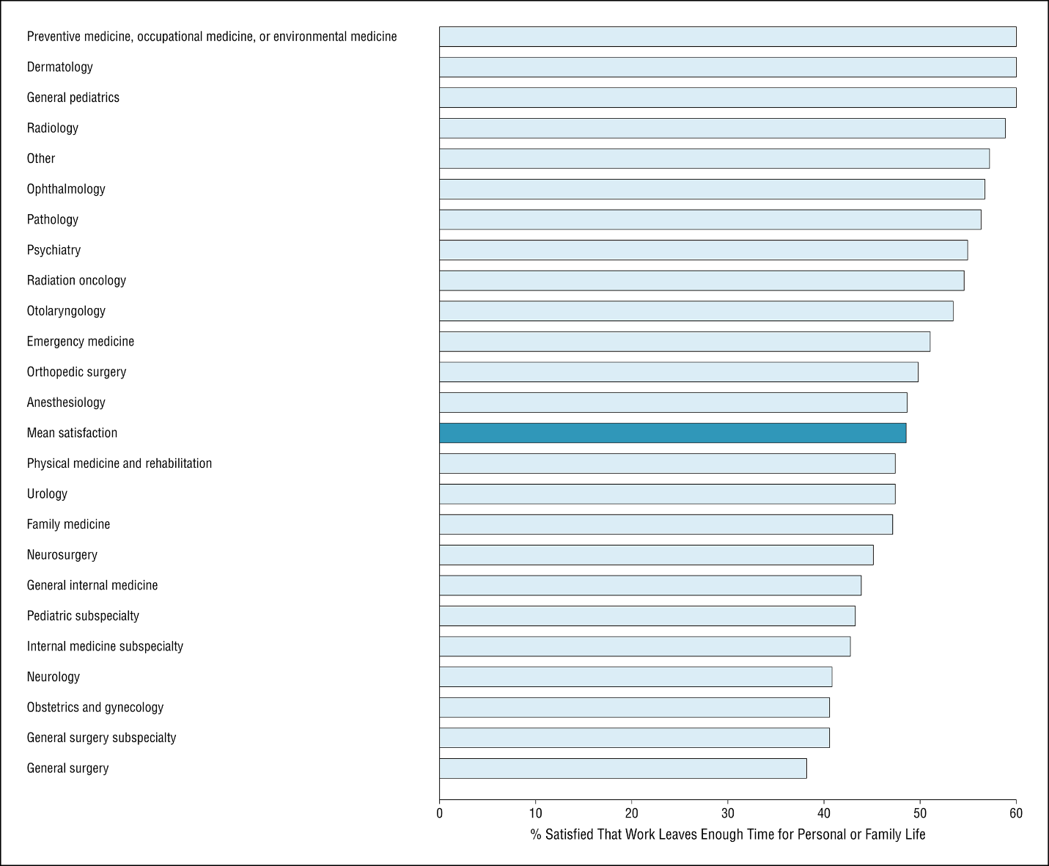
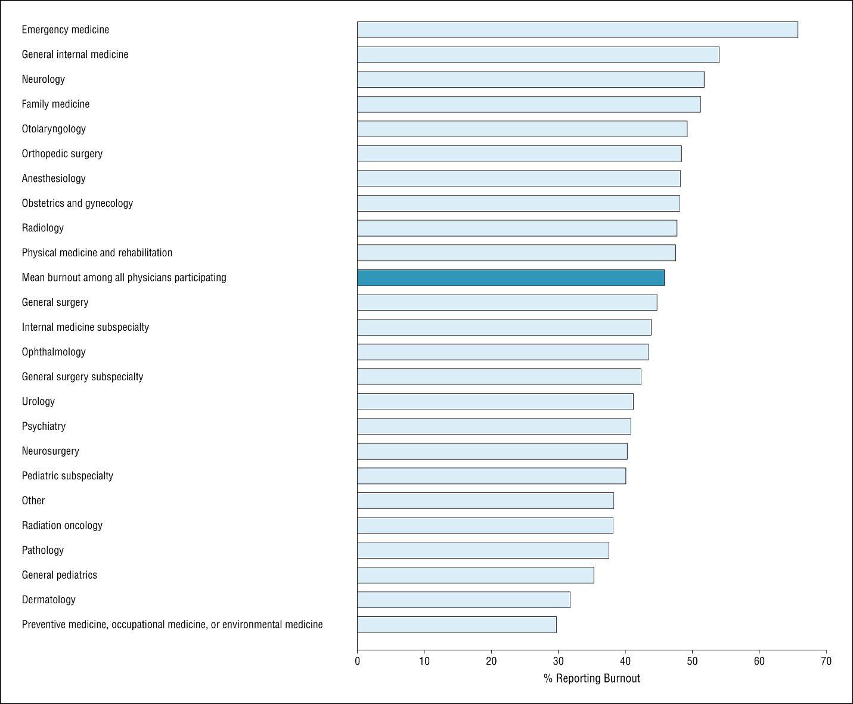

International Applicants & IMGs
Many international medical graduates (IMGs) train in occ med. The 2021 AAMC ACGME Report on OEM residents (grouped with GPM & Aerospace) shows that 30% of OEM residents are IMGs, greater than the national average of 23% (source). The American Medical Association (AMA) has a quick article on IMGs, here. In short, the Educational Commission for Foreign Medical Graduates (ECFMG) certifies graduates of medical schools located outside of USA/Canada (IMGs) to apply to U.S.-based graduate medical education.
Unless the IMG already has approval to work in the US (such as a green card or citizenship), he or she will also require a visa and sponsorship as an international applicant. There are different types of visas, and the process can be challenging. Few if any occ med residency programs can sponsor visas, contingent on their funding sources. The IMG applicant will need to have completed an ACGME-accredited PGY1 year and applicable licensing exams before beginning the OEM program. Whereas IMGs commonly apply to and attend OEM residencies, international applicants requiring visa sponsorship are uncommon in OEM residencies.

Questions or feedback? Contact Erin Ransford, ACOEM's Director of Engagement, at erin@acoem.org.

